Justin Cray

04/17/18

AMRUPT, SP18

**Goals**

My goals for this week were to order antennas for the SDRs and get the SDRs to be operational in some capacity.

**Problem**

While I did get the SDRs working, the signal quality was much lower than expected.

**General Approach**

I followed the tutorial for the SDR startup guide here:

https://cdn-learn.adafruit.com/downloads/pdf/getting-started-with-rtl-sdr-and-sdr-sharp.pdf

It was pretty straight forward once the hardware was operational. Russell and I spent a decent amount of time trying to figure out how to get the hardware working, which resulted in ordering more male to female USB adapters.

**Planned Course of Action**

I am curious to see if the signal quality improves with better antennas. The next step I think is to extract the I/Q values and phase disambiguation.

Here’s some results:

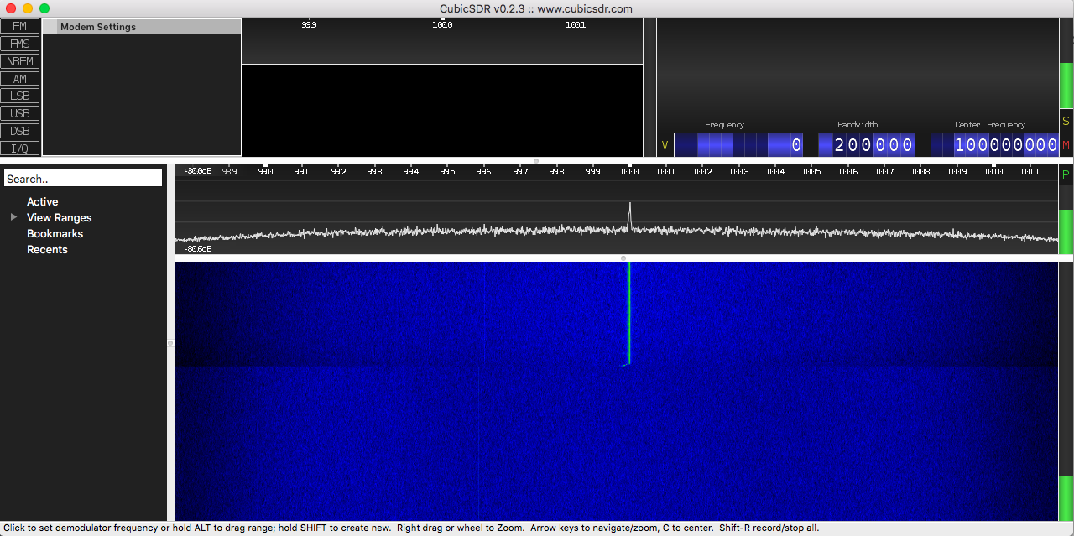

SDR Plot with no antenna, basically all nosie

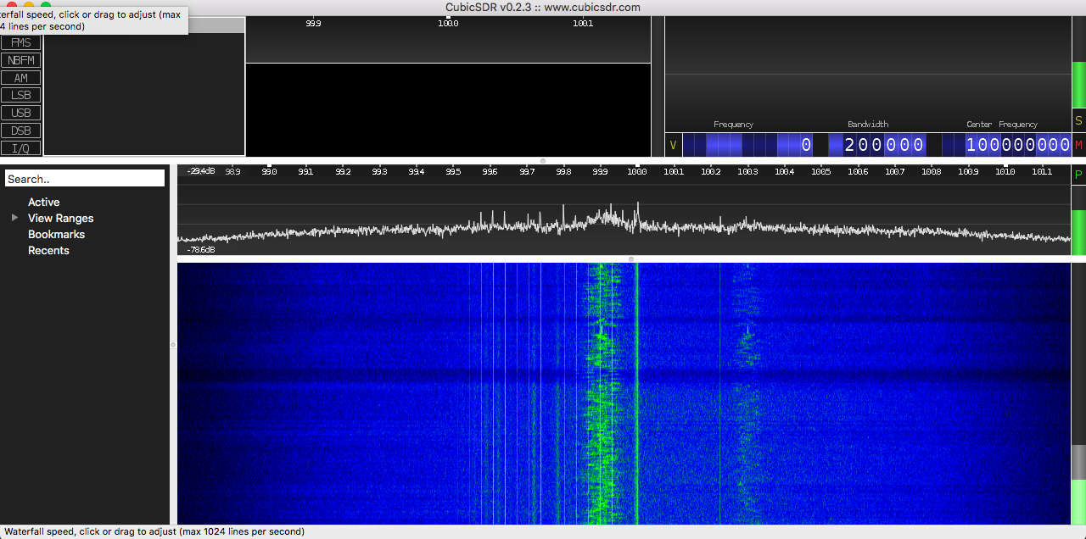

With antenna, we pick up certain FM stations